New York National Guard Youth Program |  |  | MONTHLY NEWSLETTER  SEPTEMBER ISSUE
Believe ~ Hope ~ Imagine ~ Inspire
Welcome to the first issue of the Youth Program Newsletter. This newsletter is designed to keep all National Guard families informed, and up to date with all the services, programs and information that the Youth Program has to offer.  Our mission is to reach and inform all guard youth on challenges that they are facing, and to share  Opportunities and activities that are available to deal with those challenges.  This Program is youth Driven. This means that all your ideas and concerns will be addressed and implemented to the best of our ability. Our Vision is to provide fun, activities, services and training for all Guard Youth.  Unity is Strength  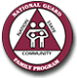 | 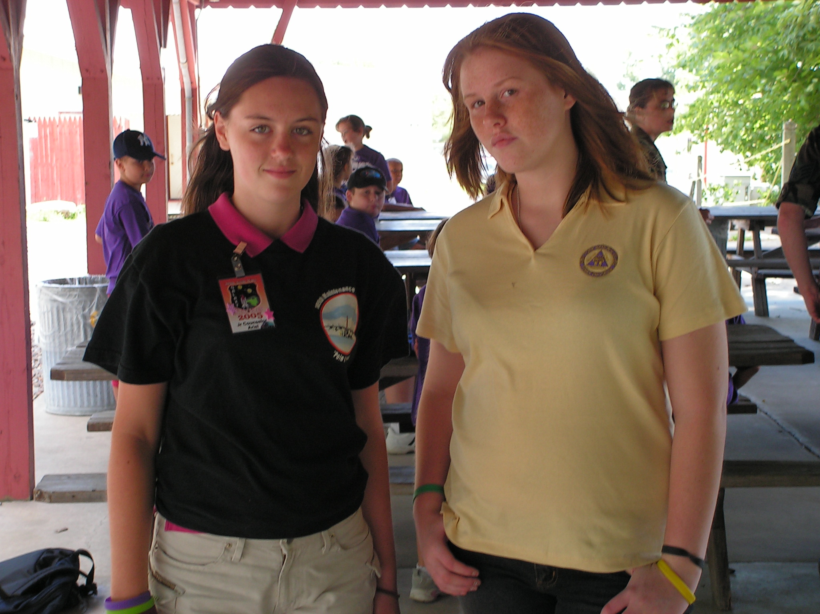

2005 National Youth Symposium
The workshop and youth symposium is an annual event for the National Guard Family Program, and this year was the first year I was able to attend. This years Symposium was held in Historical Boston Massachusetts. As your Youth Program Coordinator I was able to meet with other Coordinators from 53 states and over 100 teen leaders. To say the least I was very impressed with all the teens and their leadership skills. We were all able to connect and get to know what other states are doing with their youth programs. This is a fairly new program for most states. The skills and programs that I was able to obtain will help and benefit our state and Youth in many ways. I am very excited to begin this wonderful program. At this time I would like to introduce our New York Teen Delegates Leaders; Ariel Reed (Air National Guard teen) and Jessy Faubion (Army National Guard teen). Ariel and Jessy learned to help others teens and youth and were able to talk and think of ways they can help make deployments easier for kids of all ages. When the Teen Leaders were not training they were able to tour Boston, we all had a great time. At the end of the Symposium all the Teens presented the rest of the conference with youth created public service announcements. What a great bunch of Teens!! I had a lot of fun with all Teens and I am very proud to be a part of the Guard Family! One Team, One Voice! Goooo Guard!!!
 | HELP WANTED
Authors: Do you know funny jokes? Do you have a story you want others to know about? Write an article for us. Please share with us. Make this YOUR newsletter.
Artists: We need your help now. Send us your artwork to be published in YOUR newsletter.
Designers: Do you have a flair for design? Help build a website, suggestions for your Newsletter. Let us know!!
Photographers: Photo of the Month, Photos of special events, share a smile
Poets: Do you have a poem about your parent being deployed? Do you have a poem about being a military kid? Please send us your poetry.
If you are between the ages of 1 and 18, email or fax your gifts to the Youth Program.
All submissions should be sent to: Shelly Aiken~Program Coordinator:
Camp Smith Bldg 501
Cortalndt Manor, NY 10567
Fax: 914-788-7407
shelly.m.aiken@ny.ngb.army.mil

Services Available  Operation Military Child Care: 1-800-424-2246 or visit:  www.naccrra.org/MilitaryPrograms  Operation Military Kids: 315-788-8450 x269 or visit:  www.operationmilitarykids.org  Military One Source: 1-800-342-9647 or visit:  www.MilitaryOneSource.com  User ID: military  Password: one source  Scholarships For military youth:  www.militaryscholar.org  Military Child Education Coalition:  www.militarychild.org  National Military Family Association:  www.nmfa.org  National Guard Youth:  www.guardfamilyyouth.org  The Military Child In transition and Deployment:  www.militarystudent.org  STOMP: Specialized Training Of Military Parents:  www.stompproject.org  Military Teens On the Move:  www.dod.mil/mtom  Helping Kids learn about Being A Veteran:  www.va.gov/kids  Back To School and More:  www.kidsource.com | Child, Youth and Family Service Information
CHILDCARE SURVEY

In order to ensure that families' needs are being met, a Child Care Needs Assessment has been developed by the National Guard Child and Youth Program. This brief assessment will aid them in understanding how they can facilitate this process. Please visit www.advancedsurvey.com/default.asp?SurveyID=21294
And complete the survey. Let National Guard Bureau know what YOUR childcare needs are during deployments and other Guard situations.

*********************************************************************

National Guard Bureau Family Program Online Community
www.guardfamily.org

This is a place to find contacts, information on programs and benefits, and more. Tips, tools, and training on family issues are at your fingertips.

*********************************************************************
National Guard Youth Site

www.guardfamilyyouth.org

This National Guard Youth Community site is for you! It provides information on subjects such as stress management, health and fitness, how to be a friend, and how to deal with your parent's deployment.

*********************************************************************

Real Teens Connected

Army Teen Website’s official launch date is due for October 31st 2005. Although targeted at Army teens for now, it will soon be for any military affiliated teen in the near future. The AFTB for teen’s project will take up to two years to complete. This training is for teens and taught by teens. It’s a great way to learn about the Army and different aspects of being an Army teen. The web address is www.realteensconnected.com. If you have any questions about this program contact: Texas Teen Delegate: Camerand
gumby8827@aol.com

Readiness is Wellness

Military Child care in your Neighborhood

This service is provided for all Military Branches
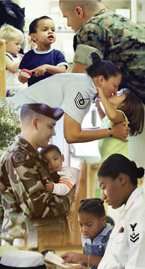
Military Child Care in Your Neighborhood is a Department of Defense (DoD) program designed to meet the child care needs of Service Members living in areas where on-base military child care is not available. Eligible Service Members include Recruiting Specialists, Reserve Office Training Corps (ROTC) instructors, Military Entrance Processing (MEP) personnel and Service Members on independent duty assignments who cannot access the high quality care available on military installations.
In the past, these families bore the full cost of their child care. Now with Military Child Care in Your Neighborhood, many of them will be eligible to pay reduced fees for the care of their children. To meet this need, the DoD has asked NACCRRA to partner with state and local Child Care Resource and Referral Agencies (CCR&Rs) to locate or develop high quality child care spaces that meet DoD quality standards, and provide fee assistance to lower the child care cost to military families.
The civilian child care programs that provide Military Child Care in Your Neighborhood child care spaces are comparable in quality to Military operated on-base spaces and meet most DoD and Service standards.
The following are examples of programs that DoD considers quality care:
- Nationally accredited child care centers or FCC homes
- FCC homes with a CDA credentialed provider
- Federal or GSA accredited centers
Note: Military Child Care in Your Neighborhood services are not an entitlement and are subject to geographic availability of care and DoD and Military Service funding.
How exactly will Military Child Care in Your Neighborhood work?

How it Works

The following is the process for obtaining quality, off base child care at reduced rates:
- The Service member, spouse, or legal guardian contacts Child Care Aware, a division of NACCRRA, toll-free at 1-800-424-2246 or via the web at www.naccrra.org to determine eligibility. If eligible, families can enroll by using the NACCRRA web page and clicking on the link for the appropriate military Service.
- Applications can be initially completed online or faxed.
- NACCRRA staff will collect information from the Service or family member to determine eligibility and specific child care needs.
  - In addition to the parent and provider application, NACCRRA requires the following documents (copies). The Service or family member must provide NACCRRA (via email, fax, mail) copies of the following:
    - Service member’s military orders
    - Leave and Earnings statement (LES) for both the Service members and spouse (most recent month)
    - Child(ren)’s birth certificate(s)

- Callers are given enrollment information about available child care spaces in quality civilian community child care programs. Callers are referred to their local Child Care Resource and Referral (CCR&R) agency for available quality spaces.

Operation Military Kids at the State Fair
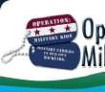
As part of a nationwide effort to support children of deployed National Guard and Reserve service members, Operation: Military Kids- New York (OMK-NY) will have a mobile technology lab (MTL) available for use from10:00 am until 7:00 pm on August 27-28 and September 3-5 in the State Fairgrounds 4-H Youth Building.

All military kids (including Active Duty, Reserve and National Guard) will be invited to use the available laptop computers, scanner, printer, video recorder, digital camera and software to create personalized messages and gifts for their loved one overseas. Hero Packs, book bags filled with goodies, will also be distributed to families of deployed Reserve and Guard service members.

All children and youth must have their military ID or be accompanied by another military ID card-carrying family member. For statistical purposes, please be prepared to identify the sponsor’s unit.

Operation: Military Kids is a partnership of Army Child and Youth Services, USDA National 4-H Headquarters, and the Cornell University Cooperative Extension
4-H Youth development.

For more information or to become involved with Operation Military Kids, please contact:
Kelly Sherman,
New York 4-H Military Liaison and OMK-NY Project Director:
(315) 788-8450 or omk-ny@cornell.edu.

- NEW YORK STATE FAIR

Syracuse, New York
Thursday, 1 September is
Veteran's Day
Fire & Rescue Day
And
City Youth Organization Day
At
The New York State Fair
Show a current military ID or form DD214 and you will be admitted to the fair for free.

Galaxy-Hercules Program

This past week I was able to visit the Youth and Teens at the Annual Galaxy-Hercules Camp at Stratton Air National Guard Base.
This Camp is now combined with Air and Army dependants. I had a chance to talk to all the Kids, and ask them to share their ideas with me. The majority of the children would like to see Sleepover Camps for Military kids. I was very excited to let them know that it is my job to do just that for them!! The Youth Program will start Camps next summer 2006 and look forward to combining both Air and Army dependants, making this a truly Purple program. It was great to meet all the youth at the Air Base and I look forward to seeing them next year.

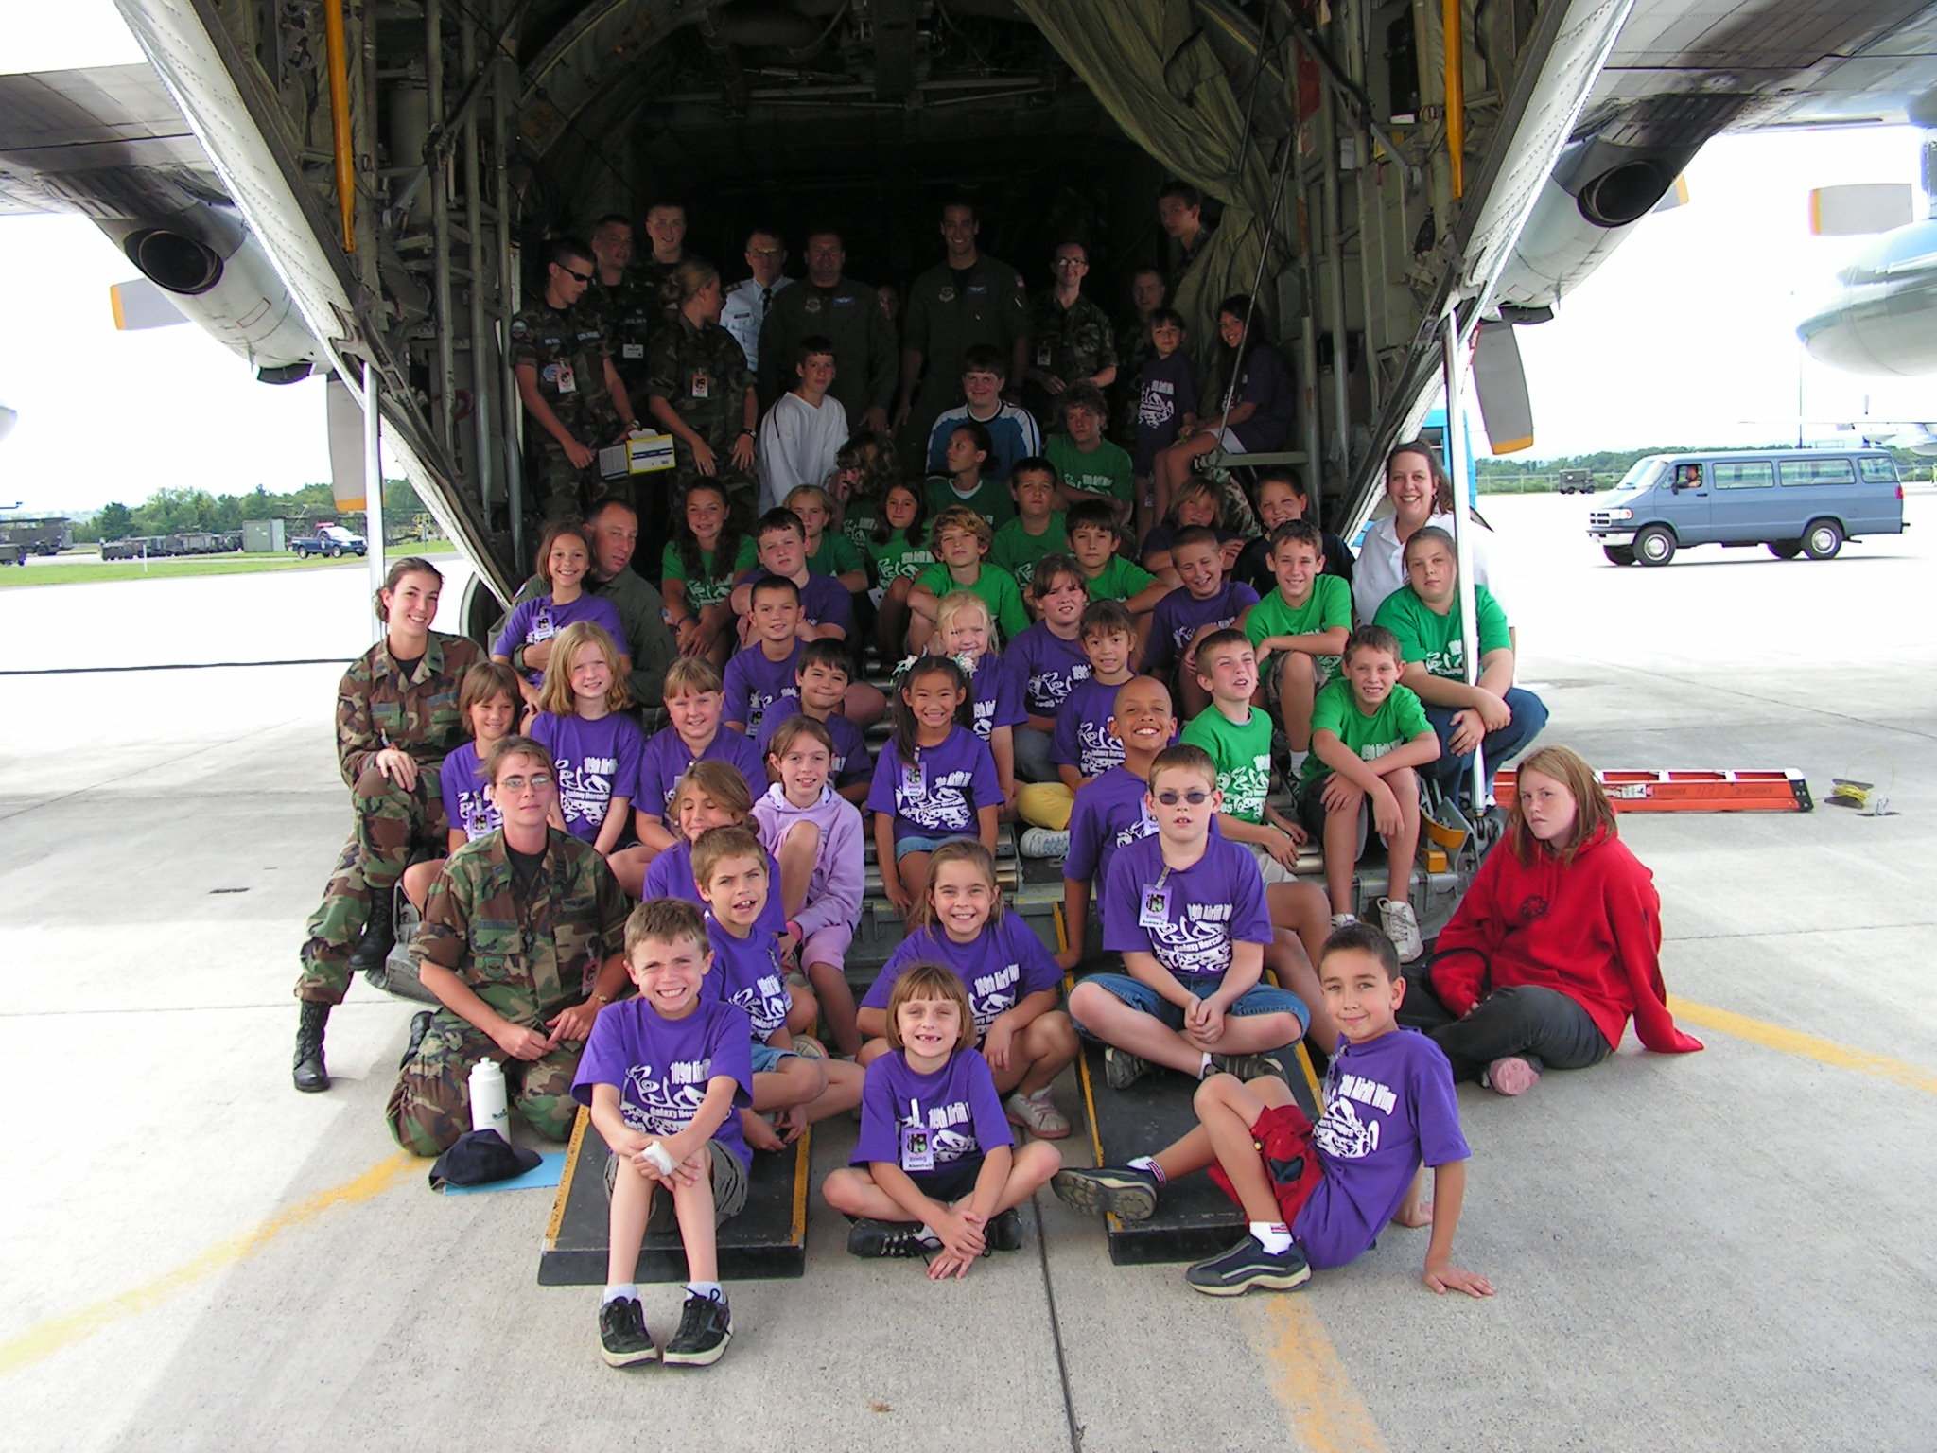

Summer 2005
109th Air Wing Stratton Air Base
Scotia, New York

Back to School Tips

For Teens:

After a summer of sleeping in or doing things on your time, the alarm bell announcing that first day of school can be a rude awakening. Whether you're an anxious new freshman or a confident senior, heading back to school signals a time of transition: new classes, new teachers, new schedules, and a new social scene.
Dread it or love it, you gotta go to school. Here are some ways to make the transition from summer to school a little easier.
First-Day Mania
There's no escaping the fact that the first day of school can be crazy. New kids wander around in circles. Lockers won't open. The school nurse needs your medical records. You forgot your gym shorts. Freshmen are running in all directions, looking for their homerooms.
How can you combat first-day chaos? If you're headed to a new school, try to arrange a visit before classes begin. Explore any areas that are of particular interest, such as the gymnasium, library, or science labs. Some schools offer maps. Get one and give it a read before school starts - then keep it in your backpack until you're familiar with your new surroundings.
Your first day is also the time to bring in school supplies and paperwork. It can help to pack your backpack the night before school starts so you're not scrambling around at the last minute looking for what you need. In addition to packing basic supplies (such as notebooks, pens, pencils, and a calculator), hunt down any of the school forms that were mailed to your family over the summer: immunization (shot) records, permission slips, and class schedules.
Did you try on eight different outfits before deciding what to wear? Lots of people check out who's wearing what on the first day of school. The key is to wear what makes you feel good, whether it's a brand-new outfit or a comfy old sweater. If you plan to wear a new pair of shoes, break them in a few days beforehand or your feet may scream for relief long before last period.
Each school has a different opening-day drill. Some start with homeroom or an assembly, but others may jump right into the first-period class. You'll meet your new teachers, and they'll probably give you an overview of the course syllabus, class rules, what the semester will be like, what supplies you'll need, and expectations of your performance and behavior. Some teachers will jump right into their first lesson, others may have non-coursework activities planned. It all depends on the class and teacher.
Emotions
Here's a simple equation: new place = new emotions. Lots of people feel anxious, scared, or excited about school. Although people who are coming back as seniors may be happy they're in their final year and can't wait to visit with friends, most freshmen or new kids are likely to be tense or worried.
It's perfectly normal to feel nervous the first day of school. Getting back to the school routine and adjusting to new workloads takes some getting used to after a long summer break. If you're having a mental meltdown, think back to some previous "first days." Everything probably settled down pretty quickly once you got into the routine.
Meeting new people or getting reacquainted with classmates can feel overwhelming, especially if you're the shy or reserved type. Start small: If large groups make you nervous, try saying hi to one or two new
Back To school continued…

people a day - the kid at the desk next to yours in homeroom is a good place to start. Or ask new people to sit with you in the cafeteria.
If you still feel uncomfortable after a few days, talk to the school guidance counselor, a favorite teacher, or someone else you trust about how you're feeling and what you can do. But give yourself time - most problems adjusting to school are only temporary.
Making Your Way Through the Lunchroom
What's everyone's favorite period? Lunch, what else? With foods like tacos, pizza, or cheeseburgers staring you in the face when you're at your most hungry, it can be hard to make healthy choices.
Here are some tricks to choosing the foods that will keep you focused and active throughout the day - as well as help you grow and develop throughout the school year:
- Get a copy of the menu. If your cafeteria provides a weekly or monthly menu, check it out. Knowing what's on the menu puts you in control: You can pick and choose which days you want to buy lunch and when you want to bring your own.
- Head for the salad bar. If your school offers a salad bar or juice machine, take advantage. If you'd rather pack, consider adding carrot sticks, a fruit cup, or pretzels to your lunch bag.
- Think energy. Some foods are better choices than others for maintaining energy during the day. Choose low-fat proteins, like chicken, beans, or low-fat yogurt and add lots of fruits and veggies to your meal. They'll provide the vitamins and minerals you need and the energy to get through the day. Foods that have a lot of simple carbohydrates, like sugary snacks, donuts, or french fries may give you a quick rush of energy but it's not sustainable - which means you'll be left wanting more soon after you eat. The same is true of drinks filled with caffeine or sugar. You don't have to cut these out entirely - just enjoy them in moderation.
- Stop for a snack. You can't concentrate or absorb new knowledge without a well-fed mind and body. So take along a healthy snack, like carrot sticks or trail mix, to stave off hunger between classes (don't munch during class, though, or you may face a reprimand!). Not only will this keep you going, it will also help you avoid overeating when mealtime finally arrives.
School is a time to make friends and try new things, but it's also a place to learn skills like organization and decision making that will come in handy for the rest of your life.

For Youth:
It's school time again! You're probably feeling excited and maybe a little sad that summer is over. Some kids feel nervous or a little scared on the first day of school because of all the new things: new teachers, new friends, and maybe even a new school. Luckily, these "new" worries only stick around for a little while. Let's find out more about going back to school.
The First Day
Most teachers kick off the school year by introducing themselves and talking about all the stuff you'll be doing that year. Some teachers give students a chance to tell something about themselves to the rest of the class.
When teachers do the talking on the first day, they often go over classroom rules so you'll know what's allowed and what's not. Pay close attention so you'll know if you need to raise your hand to ask a question and what the rules are about visiting the restroom.

Back to School continued…

You might already know a lot of people in your classes on the first day. But it's a great day to make a new friend, so try to say hello to kids you know and new ones that you don't. Make the first move and you'll be glad you did and so will your new friend!

Get Oriented
The first day of school is your first chance to find your way around a new school, or learn the pathways to new classes in your old school. It's a lot to learn in one day, so don't be surprised if you need a reminder or two.
It might help to write a few notes to yourself, so you'll remember the important stuff, like your locker combination and that lunch starts at 11:43, not 12:10. Before you know it, your fingers will fly as you open your locker and you won't have to check your notes to know what time lunch starts!
A Bad Start?
What if you hate school by the end of day one? Teachers recommend giving things some time to sort themselves out - once you know your way around the building and get adjusted to the new routine, you'll probably feel better. If those feelings don't fade, talk to your mom, dad, teacher, or school counselor.
Here are a few final tips for a fantastic first day:
- Get enough sleep.
- Eat a healthy breakfast.
- Try your best.
- Develop good work habits, like writing down your assignments and turning in your homework on time.
- Take your time with school work. If you don't understand something, ask the teacher.
- Keep a sense of humor. One teacher we know shows his new students a picture of himself graduating high school - a grinning ape in a red graduation cap and gown. This usually makes the kids laugh, and it's a good way to remind them that school is fun!
Have a Fun, educational and safe year!!!
New York National Guard Youth Program | State Family Program Office
Shelly Aiken~Program Coordinator  Camp Smith, Bldg 501  Cortlandt Manor, NY 10567  (Phone) 914-788-7405  (Fax) 914-788-7407  (Cell) 845-727-0628  shelly.m.aiken@ny.ngb.army.mil | Program Director- Beverly Keating: 518-786-4525  GFTB/GFAP/Mgr– Stephanie Duell:518-786-4614  SFPO Asst./MFAC- Dyette Putnam:518-786-4656  Or Call Toll Free:  1-877-715-7817

New York National Guard
Youth Program



Name Our Web Site Contest
(This Web Site is designed for all National Guard Children)

WHO CAN ENTER: ALL Guard Children ages 5-18

WHAT: Name Our Web Site
Let your imagination go…

DEADLINE: September 5th 2005

SEND ENTRIES TO: shelly.m.aiken@ny.ngb.army.mil

For more Info Call: 914-788-7405

The Winner of the “Name our Web Site” contest will receive a $100.00 Gift Certificate of their choice!!!

